**Pollinator Garden Planner**

User Guide

North Carolina State University

Department of Applied Ecology

CSC 492 Team 5:

Kevin Bartushak

Noel Drotor

Tammy Le

Carolyn Thompson

North Carolina State University

Department of Computer Science

December 14, 2018

**Introduction** **2**

**Create Account/Login** **3**

**Create New Garden Project** **4**

**Open Existing Garden Project** **5**

**Edit Garden** **6**

**Search Plants** **8**

**Filter Plants** **9**

**View Garden Space** **10**

**Check Garden** **11**

**Generate Shopping List** **13**

Introduction

The Department of Applied Ecology (DAE) at North Carolina State University is sponsoring a Computer Science Department senior design project to develop a web-based garden design and visualization app for novice gardeners, expert gardeners, and homeowners to promote the health of pollinators by creating beautiful home gardens with pollinator plants. The senior design team’s solution to the DAE’s request is a web application called Pollinator Garden Planner that will meet the following functional requirements: creating an account, logging in, creating a garden project, open an existing garden project, filtering the plant list, searching for plants by name, viewing the garden space, checking the garden against criteria that makes a successful pollinator garden, and generating a shopping list.

This document guides a user through the necessary steps to create a pollinator garden and receive a shopping list of their plants.

Please navigate to <website link> in a browser to access the Pollinator Garden Planner.

Create Account/Login

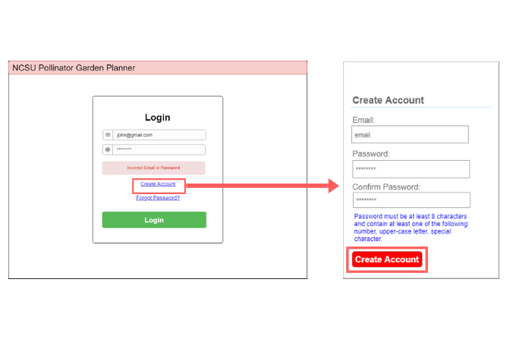

Steps

1. Previously registered users must login by:
   1. Entering your email
   2. Entering your password
   3. Clicking “Login” to advance to the next page
2. New users must click “Create Account” on the login page
   1. Enter your email
   2. Enter your password
   3. Re-enter your password to confirm password
   4. Click “Create Account” to advance to the next page

Password Forgotten

1. On the login page, click “Forgot Password?”
   1. Enter your email and click “Reset Password”
   2. If the email you entered is associated with your account, a reset password link will be sent to that email.

Create New Garden Project

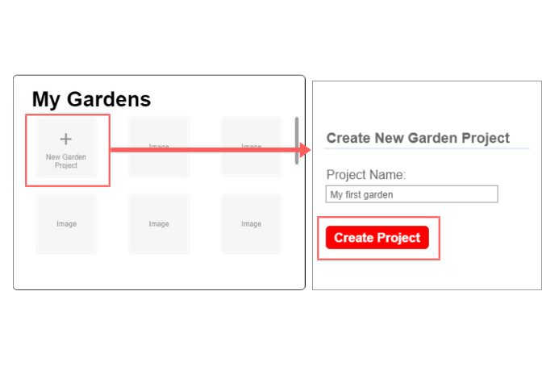

Steps

1. After logging in, you will be directed to a new page with the “My Gardens” popup. Click the thumbnail with the plus symbol labeled “New Garden Project.”
   1. Enter a name for your garden.
   2. Click “Create Project” to advance to the next page.

Open Existing Garden Project

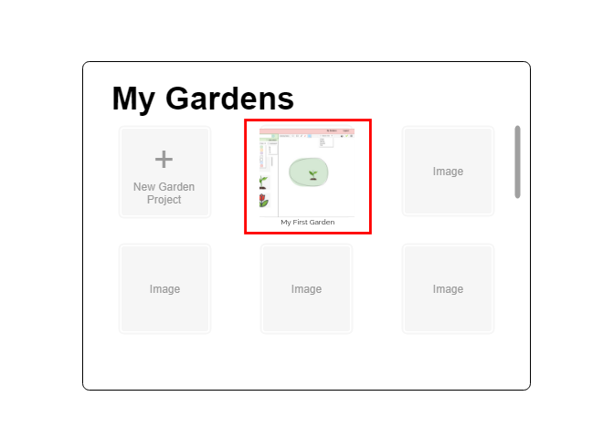

Steps

1. You must be a previously registered user, have a previously created garden and be logged in.
2. Click on the thumbnail image of a previously created garden. This will advance you to the next page in the application.

Edit Garden

### 

Feature 1 Steps: Draw a Garden Area

The following instructions refer to icons found in the above diagram under the label “1”.

1. To draw an ellipse shape, click the circle icon.
   1. Click and drag anywhere in the large screen area below area 1 in the diagram.
2. To draw a rectangle shape, click the rectangle icon.
   1. Click and drag anywhere in the large screen area below area 1 in the diagram.
3. To freehand draw a black line, click the pen icon.
   1. Click and hold to freehand draw in the large screen area below area 1 in the diagram.
4. To erase, click the eraser icon.
   1. Click and hold to freehand erase in the large screen area below area 1 in the diagram.
5. To freehand color areas with colors and texture, click the colored box drop down and select your preferred color/texture.
   1. Click and hold to freehand color in the large screen area below area 1 in the diagram.

Feature 2 Steps: Drag and Drop Plants

The following instructions refer to highlighted area “2” in the above diagram.

1. To add a plant to your garden, click a plant image in the left panel and drag it into the garden area on the right.

Search Plants

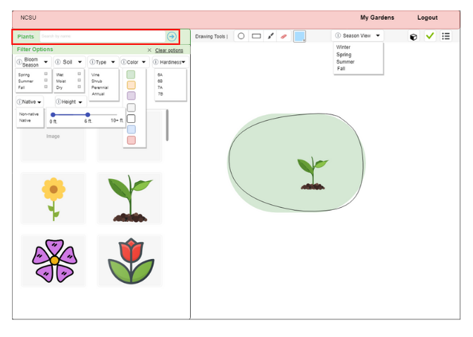

Steps

1. To search for a plant by name, enter its common or scientific name in the search bar and click the arrow to the right of the bar. This will change the left panel contents to the search result(s).

Filter Plants

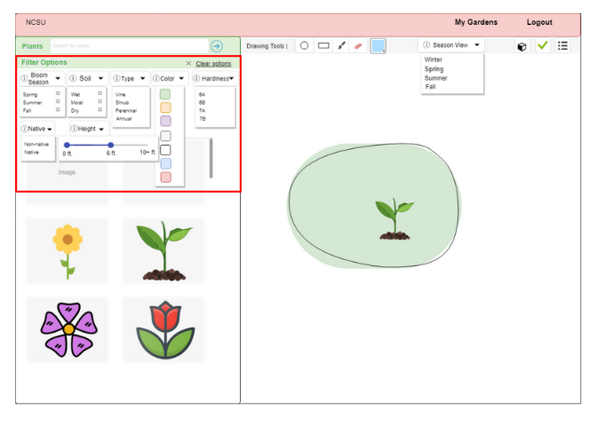

Steps

You can select multiple filter options to filter plants by. Hover the cursor over the “i” icon beside the filter options to learn more information about them.

1. To filter plants by bloom season, click the bloom season drop-down and check the boxes of season(s)
2. To filter plants by the soil type they need to grow in, click the soil type drop down and check the boxes of soil(s)
3. To filter plants by type, click the type drop-down and select any of the options
4. To filter plants by color, click the color drop down and select color(s)
5. To filter plants by hardiness, click the hardiness drop-down and select a hardiness zone value
6. To filter plants by nativeness, click the native drop-down and select non-native or native
7. To filter plants by height, click the height drop-down and then click and drag the end(s) of the height range bar to select a range of height
8. To clear filter options, click the “clear options” link at the top right of the highlighted area in the above diagram

View Garden Space

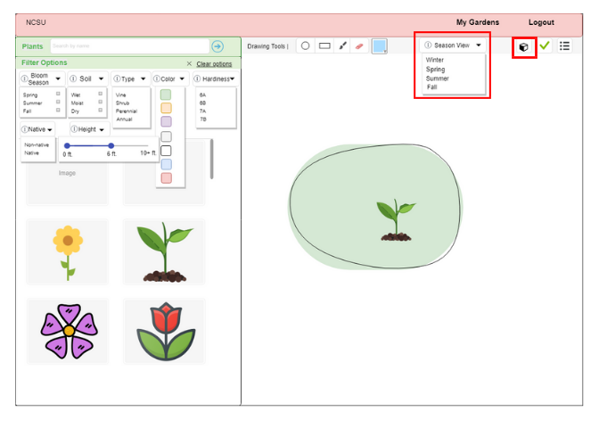

Steps

1. To view your garden in a different season, click the season view drop-down and select a season
2. To switch the perspective view of the garden between top-down and side views, click the cube icon

Check Garden

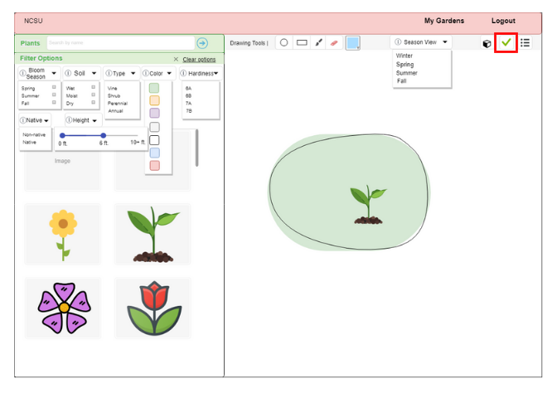

Steps

1. To check the success of your pollinator garden, click the check icon. This will advance you to the check garden page (see below).

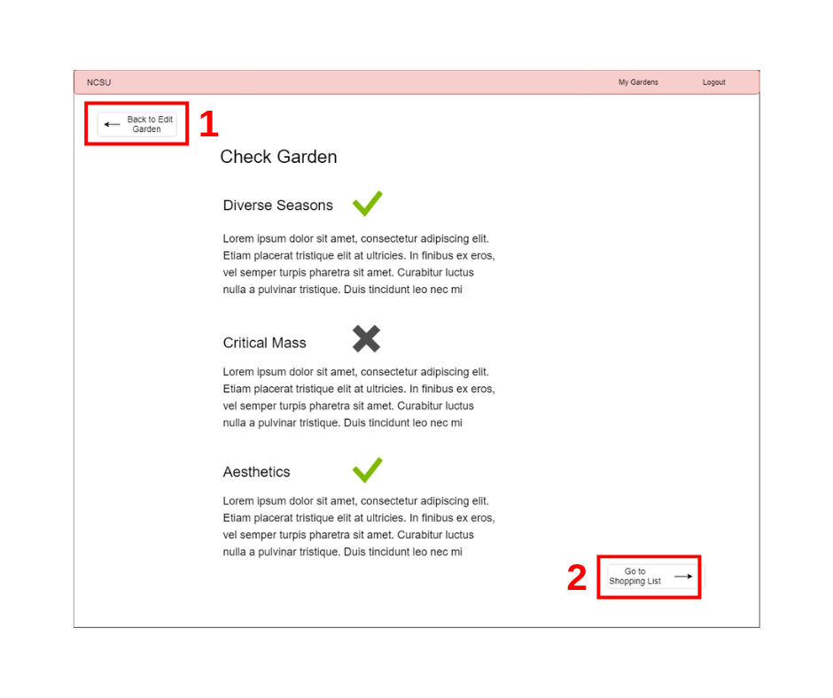

Steps

1. To go back to the edit garden page, click the Back to Edit Garden button (the highlighted button labeled 1).
2. To proceed to the shopping list, click the Go to Shopping List button (the highlighted button labeled 2).
3. Check garden criteria are listed on this page. If a requirement has a checkmark beside it, your garden has fulfilled that specific requirement. If a requirement has an X beside it, your garden has not fulfilled that requirement. You may proceed to the shopping list regardless of how many requirements your garden has fulfilled.

Generate Shopping List

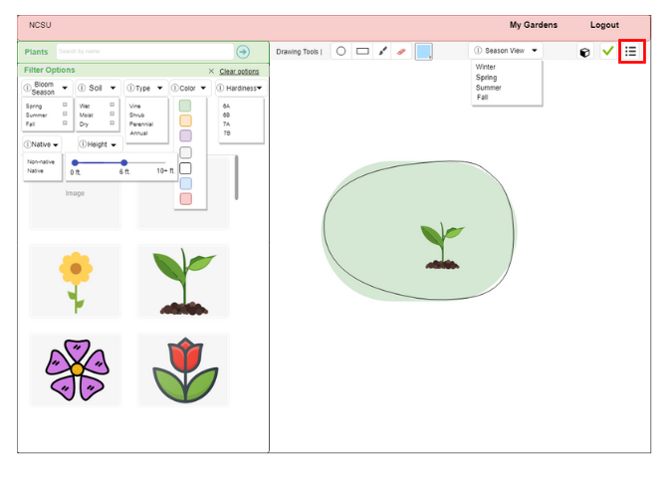

Steps

1. To generate a shopping list filled with plants from your garden design, click the list icon.